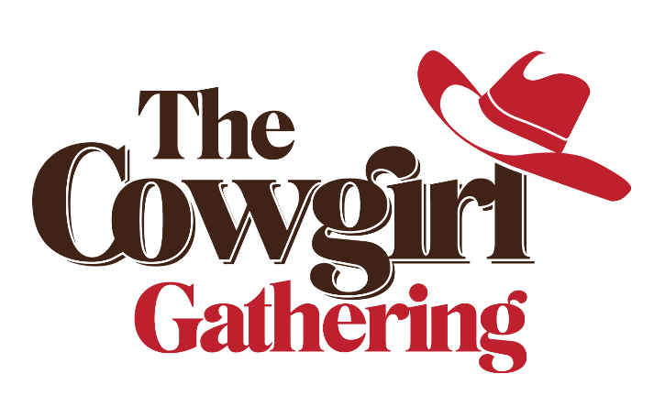

The Kimes Ranch Essence Exchange Schedule

Day #1 November 11, 2022
4:00 p.m. CST | 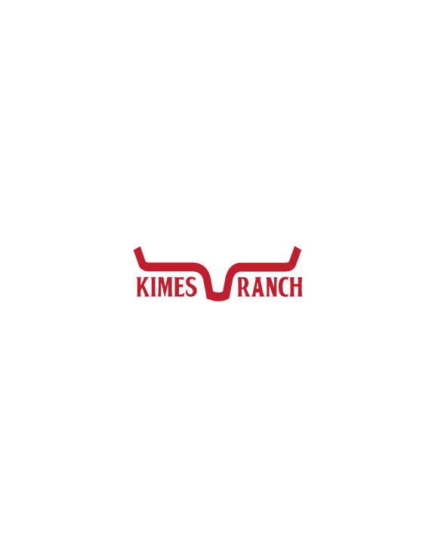  Mixer Mingle
5:00 p.m. CST | Western Sports Round-Up
6:00 p.m. CST | TBA | TBA
6:30 p.m. CST | Cowgirl Hospitality vs. Horse-potality | Nadine Lipson  Lauren Lovelace-Murray
7:00 p.m. CST | Wild Rag Wisdom | Jodi Hendrickson
7:15 p.m. CST | TBA | TBA
7:30 p.m. CST | End (Dinner on your Own)
Day #2 November 12, 2022
7:00 a.m. CST | Alumi and VIP Breakfast  (Past/Current Speakers or VIP Ticket Holders Only)
8:30 a.m. CST | Introductions | Amanda Kimes
9:00 a.m. CST | Cowgirl Comedy | Chelsea Edsall
9:30 a.m. CST | TBA | TBA
10:30 a.m. CST | Life’s A Ride | TBA
11:00 a.m. CST | Mental Edge | Barbara Schulte
11:30 p.m. CST | CATERED LUNCH
1:00 p.m. CST | Breeding | Melanie Smith  Wanda Waters
1:30 p.m. CST | Social Media | Jenna Sparks
2:30 p.m. CST | KIMES RANCH MEET AND GREET
6:00 p.m. CST | THE COWGIRL GATHERING FASHION SHOW
Day #3 November 13
9:00 a.m. CST | Cowgirl Faith | TBA
9:30 a.m. CST | Racing | Tracy Sheffield (TTA)  Janet Van Bebber (AQHA)  (APHA)
10:00 a.m. CST | TBA | TBA
10:30 a.m. CST | Cowgirls Lead The World | Laurie Rodeo (APHA)  Patty Tiberg (AQHA)  Anna Morrison (NRCHA)  Jill Dunkel (SHOT)
11:30 a.m. CST | Horses and Heroes | Tina Shanahan
12:00 p.m. CST | End

